**Create Global class in se24**

1. Go to se24.
2. Give class name starting with ZCL_. Click on create

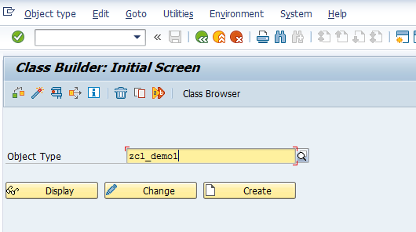

1. Give short description , choose Publicl and click Save

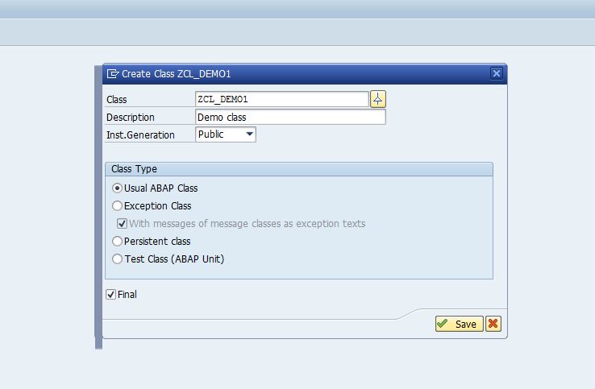

1. Go to attributes tab. Declare 2 variable V1 and V2 as shown below

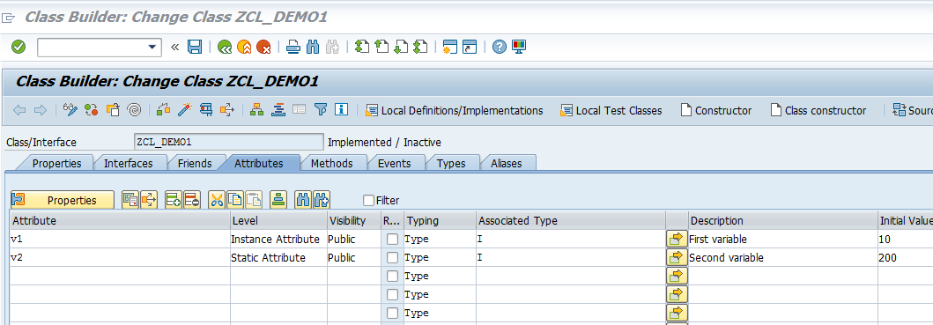

1. Save and activate the class.
2. Go to se38.Create a Report starting with Z
3. Add the below code in the Report.

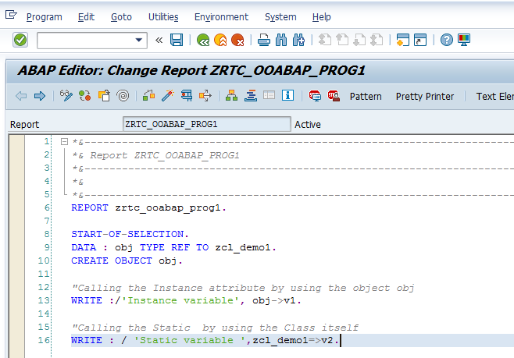

1. Save and activate. Execute. The expected output is as follows

